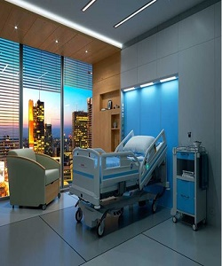

Hospital bed

$392.15

Availability: In stock

**Description:**

Modern comfortable hospital bed. Perfect for a Hospital that’s classic and functional, this is the ideal starter piece for your patients. Hospital Collection that will look stunning in your newly built or renovated. Modern white flat bed with electrical wheels to ensure stability and support.